

Contact Grill

USER’S MANUAL

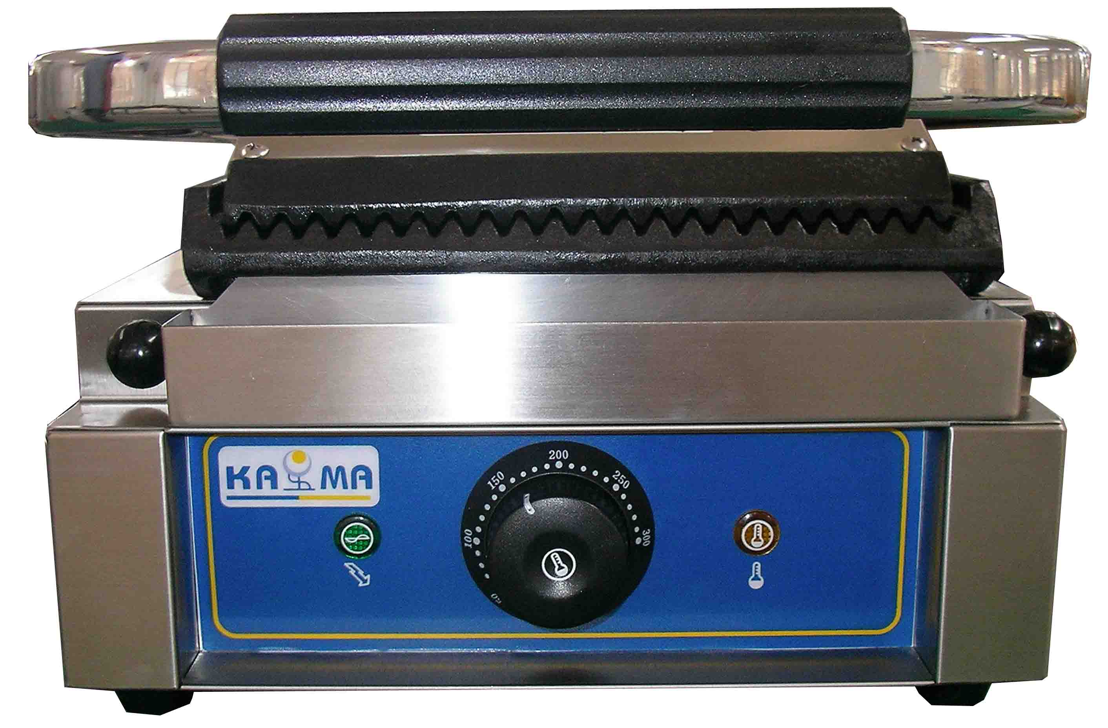
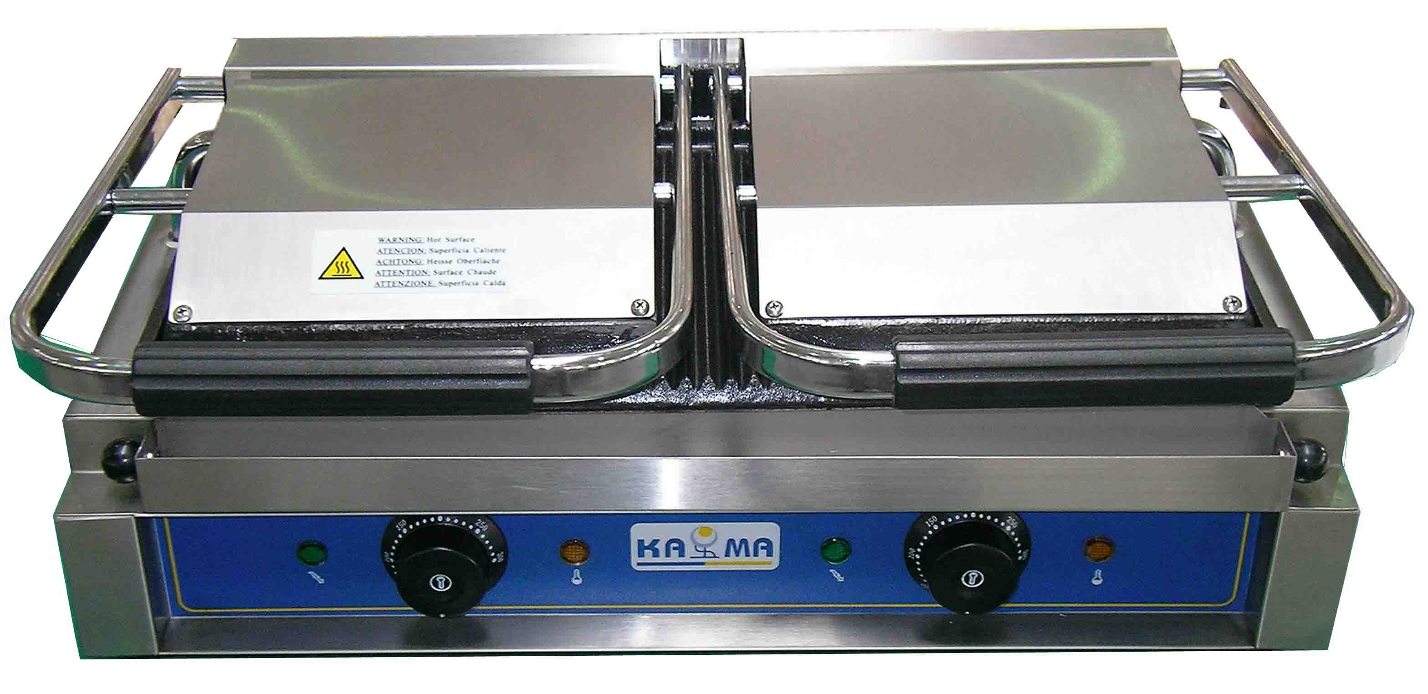

GH-811 = 90022

GH-813 = 90017, 90018, 90025

GH-811P = 90023

Structure

Fig 1. Structure of Contact Grill
1.1 The upper and lower module plates are enameled and easy to clean.
1.2 The double-headed grilling pans and independent temperature controlling system are easy to handle and can as well achieve energy saving.
1.3 Grilling temperature can be adjusted depending on different requirements.
1.4 Internal temperature protector is reliable and safe.
1.5 The whole structure is made of stainless steel.
1.6 It is easy to lift up and down, convenient to handle and maintain.

Table 1 Structure of Contact Grill
1 | Power Indicating Light | 4 | Rubber Feet | 7 | Lower Module Plate | 10 | Operation Handle
2 | Thermostat | 5 | Bottom Box | 8 | Feed Wire Tube
3 | Heating indicator | 6 | Oil Tray | 9 | Upper Module Plate

2. Product specifications
Model | GH-811 | GH-813 | GH-811P
Description | Single-head Contact grill | Twin-head Contact grill | Panini Size  Contact Grill
Voltage | 220V ~ 240V | 220V ~ 240V | 220V ~ 240V
Power | 1.8KW | 3.6KW | 2.2KW
Phase | Single | Single | Single
Frequency | 50~60Hz | 50~60Hz | 50~60Hz
Temperature | 50 ~ 300℃ | 50 ~ 300℃ | 50 ~ 300℃
Grid dimensions | 218×230mm | 475×230mm | 346 x 230mm
Size | 290×395×210mm | 570×395×210mm | 410x395x210mm
Net weight | 16kg | 28kg | 20kg
Packing size | 390x440x250mm | 670x440x250mm | 510x440x250mm
Gross weight | 18.5kg | 31kg | 23kg
Heating plate | A.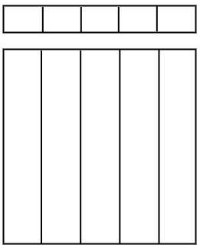 B.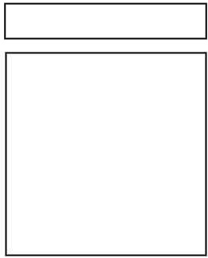  D.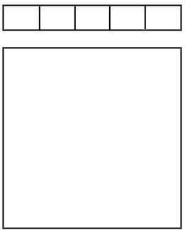 | A.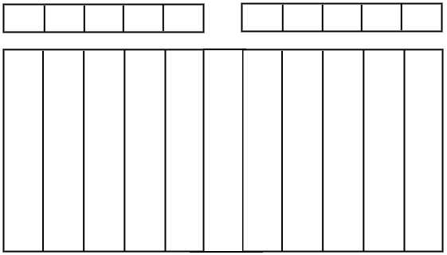 C.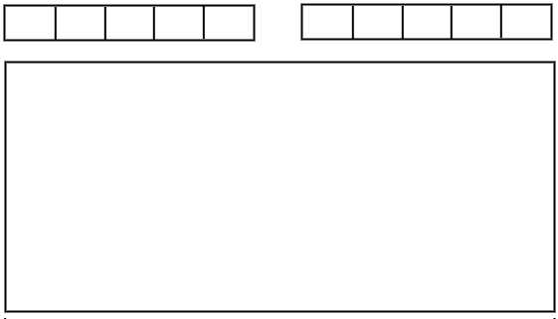 D.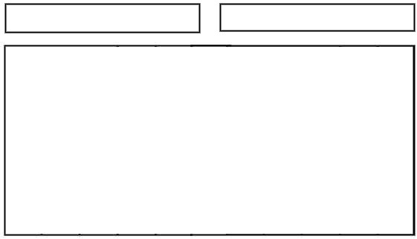 E.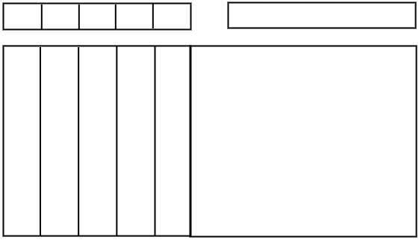 | A. B.  D.

3. Displacement and storage
During displacement, the machine should be carefully handled and prevented from jostle and collision. When still unpacked, it should not be stored outdoors but in a ventilated warehouse away from the possibility of contacting corrosive gas. It should not be placed upside down, if for any reason this product should be placed outdoors, please make sure it is safe from rain and dirt.

4. Preparation
4.1 The working voltage of the equipment should equal that of the supplied voltage.
4.2 Do not place anything on the upper module plate and do not pull the operation handle up and down with great force.
4.3 Cut off power supply while cleaning. Do not use wet cloth or any kind of corrosive substances, and do not spray water directly on the equipment.
4.4 A fuse breaker and a three-phase socket should be installed near the equipment and the ground wire should be in compliance with safety regulations.

4.5 At the back of the equipment is the ground bolt, please connect the ground wire in compliance with safety regulations preferably with copper cable of at least 2mm.
4.6 The temperature of the equipment ranges from 50 to 300 °C. It is recommended that the maximum working temperature normally should be 250°C ± 5%.
4.7 Professional technicians should do the installation and maintenance of the equipment.

5. Operation
5.1 Turn on the power switch, which will have the power light turned on.
5.2 Turn the thermostat clockwise to the desired level. Once the heat indicator is on, the machine starts warming up, so do the grill plates.
5.3 Temperature should be adjusted depending on different type of foods, preferably between 150°C -250°C.
5.4 It takes about 8 minutes for the temperature to rise to 250°C.
5.5 Once temperature reaches 250°C, lift the upper module plate. Pour cooking oil on the lower module plate and slowly begin placing food on it. Close the plates and press the handle lightly. Keep an eye on the food until it is done.
5.6 At the lower front of the lower module is the oil tray. Oil and grease flow down to oil tray from upper module plate.
5.7 Lift the upper module plate to remove cooked food.
5.8 When the temperature is low, the controller allows automatic connection to power supply. Heating elements restart heating the module plates.
5.9 On completion of work, temperature controller should be turned to “OFF” position. Unplug the equipment to cut off power.

6. Cleaning and maintenance
  - Cut off the power supply before cleaning in case of serious danger.
  - Do not use a wet towel with any type of corrosive substances to clean the module plates as well as the surface of the equipment and power cord. Washing directly with water is not suggested in case of any functional damage.
  - If not in use please turn off temperature switch and power switch.
  - Please store the equipment in a ventilated area without contact of corrosive gas.

7. Explanation drawing
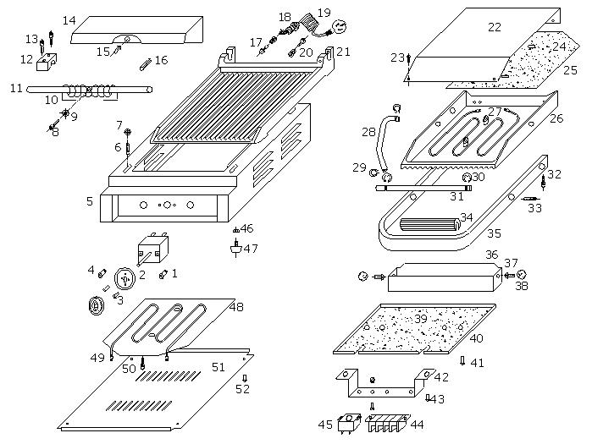
Fig 2. Explanation drawing of GH-811
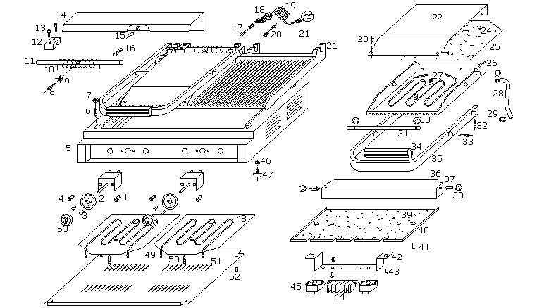

Fig 3. Explanation drawing of GH-813

8. Accessories list
Part number | Part name | Specification
GH-811-01 | Heat indicator lamp | 250V 14A
GH-811-02 | Thermostat | 250V 20A
GH-811-03 | Cross-headed screw | M4×6
GH-811-04 | Power indicator lamp | 250V 14A
GH-811-05 | Bottom hull | 430 =0.8
GH-811-06 | Hexagonal screw | M16×10
GH-811-07 | Washer | A3 chromium plating
GH-811-08 | Hexagonal screw | M5×25
GH-811-09 | Washer | A3 chromium plating
GH-811-10 | Twisting Spring | Ф3.5
GH-811-11 | Rear Rotary Axle | Ф12×278
GH-811-12 | Fixation Stand | Copper
GH-811-13 | Hexagonal screw | M6×40
GH-811-14 | Rear Hood | 430 =0.8
GH-811-15 | Cross-headed screw | M4×8
GH-811-16 | Pin | Ф4×40
GH-811-17 | Ground screw | M6×15
GH-811-18 | Power supply wire jacket | ABS
GH-811-19 | Power supply wire | 3×2.5mm
GH-811-20 | Power ground screw | M5X16
GH-811-21 | Lower Module Plate | Iron
GH-811-22 | Upper Module Seal Plate | 430 =0.8
GH-811-23 | Cross-headed screw | M4×8
GH-811-24 | Upper Module Plate Asbestos Insulation | Fiber glass
GH-811-25 | Upper Module Heating Tubes Press Plate | =1.0
GH-811-26 | Upper Module Plate | Iron
GH-811-27 | Heating Element | 800W 230V
GH-811-28 | Coil in pipe | Steel
GH-811-29 | Upper Module Axis | Ф12
GH-811-30 | Check ring | Ф14
GH-811-31 | Axes | Ф12×278
GH-811-32 | Hexagonal screw | M5×16
GH-811-33 | Hexagonal screw | M6X8
GH-811-34 | Rubber Handle | Ф30×155
GH-811-35 | Operation Handle Frame | Steel 20×10
GH-811-36 | Oil tray | 304 =0.8
GH-811-37 | Oval head nail screw | M6X12

Part number | Part name | Specification
GH-811-38 | Orb | Ф20
GH-811-39 | Heat shield
GH-811-40 | Press Plate
GH-811-41 | Crosshead screw | M4×20
GH-811-42 | Terminal board | 430 =0.8
GH-811-43 | Crosshead screw | M4X8
GH-811-44 | Line bank | 250V 16A
GH-811-45 | Qualification | 250V 16A
GH-811-46 | Hexagonal screw | M6×20
GH-811-47 | Rubber Feet | Ф30×15
GH-811-48 | Heat Element Bead | =1.0
GH-811-49 | Heat Element | 230V 1000W
GH-811-50 | Hexagonal screw | M6×8
GH-811-51 | Platter | =1.0
GH-811-52 | Crosshead screw | M4×6

9. Circuit diagram
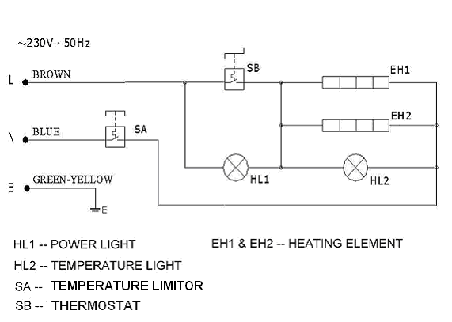

Fig 4. Circuit diagram of GH-811

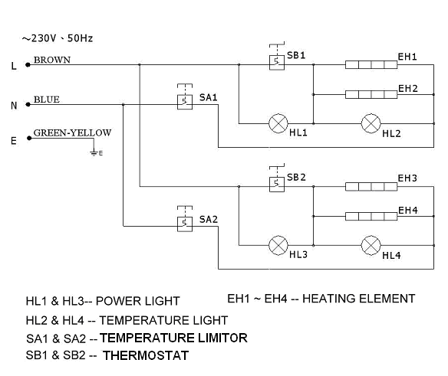
Fig 5. Circuit diagram of GH-813

10. Troubleshooting
Table 4.Troubleshooting
Problems | Causes | Solutions
Module plates out of heat when the power and heat indicator are both on. | 1)Breakdown of thermostat  2)Breakdown of electric heating wires | 1) Thermostat replacement  2) Replacement of electric heat wires
Thermostat out of order when the power is on and thermostat is switched and the heating indicator is on as well | Thermostat malfunction | Replacement of thermostat
Indicator off when the power is on and the heating process is normal | Indicator light damaged | Indicator replacement
Indicator out of order and no heat when the power is on | - Abnormal power supply or cut-off power supply  - Fuse breakage | Check power supply /or fuse replacement.
Problems mentioned above are just for reference. If any other errors occur, please stop using immediately and seek for professional help.

! Warning
Any disassembly and incorrect installation, incorrect adjustment and maintenance may lead to property loss and damage. Please contact your supplier if it is necessary to have this product repaired by professionals.

! Warning
For your own safety, do not place or store any flammable liquid, gas or other objects around or in the product.

